Media Queries

CSS uses *media queries* to adapt a website's content to different screen sizes. With media queries, CSS can detect the size of the current screen and apply different CSS styles depending on the width of the screen.

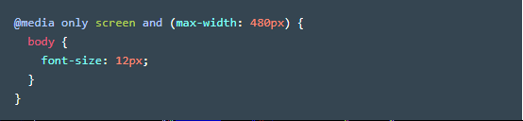

The example above demonstrates how a media query is applied. The media query defines a rule for screens smaller than 480 pixels (approximately the width of many smartphones in [landscape](https://en.wikipedia.org/wiki/Page_orientation) orientation).

Let’s break this example down into its parts:

1. @media — This keyword begins a media query rule and instructs the CSS compiler on how to parse the rest of the rule.
2. only screen — Indicates what types of devices should use this rule. In early attempts to target different devices, CSS incorporated different media types (screen, print, handheld). The rationale was that by knowing the media type, the proper CSS rules could be applied. However, “handheld” and “screen” devices began to occupy a much wider range of sizes and having only one CSS rule per media device was not sufficient.screen is the media type always used for displaying content, no matter the type of device. The only keyword is added to indicate that this rule only applies to one media type (screen).
3. and (max-width : 480px) — This part of the rule is called a *media feature*, and instructs the CSS compiler to apply the CSS styles to devices with a width of 480 pixels or smaller. Media features are the conditions that must be met in order to render the CSS within a media query.
4. CSS rules are nested inside of the media query's curly braces. The rules will be applied when the media query is met. In the example above, the text in the body element is set to a font-size of 12px when the user's screen is less than 480px.

# Range

Specific screen sizes can be targeted by setting multiple width and height media features. min-width and min-height are used to set the minimum width and minimum height, respectively. Conversely, max-width and max-height set the maximum width and maximum height, respectively.

By using multiple widths and heights, a range can be set for a media query.

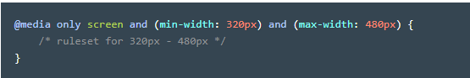

The example above would apply its CSS rules only when the screen size is between 320 pixels and 480 pixels. Notice the use of a second and keyword after the min-width media feature. This allows us to chain two requirements together.

The example above can be written using two separate rules as well:

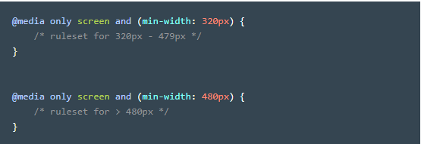

The first media query in the example above will apply CSS rules when the size of the screen meets or exceeds 320 pixels. The second media query will apply CSS rules when the size of the screen meets or exceeds 480 pixels, meaning that it will override the CSS rules present in the first media query.

Both examples above are valid, and it is likely that you will see both patterns used when reading another developer's code.

# Dots Per Inch (DPI)

Another media feature we can target is screen resolution. Many times we will want to supply higher quality media (images, video, etc.) only to users with screens that can support high resolution media. Targeting screen resolution also helps users avoid downloading high resolution (large file size) images that their screen may not be able to properly display.

To target by resolution, we can use the min-resolution and max-resolution media features. These media features accept a resolution value in either dots per inch (dpi) or dots per centimeter (dpc). Learn more about resolution measurements [here](https://en.wikipedia.org/wiki/Dots_per_inch).

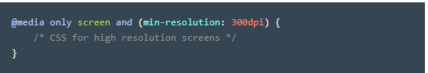

The media query in the example above targets high resolution screens by making sure the screen resolution is at least 300 dots per inch. If the screen resolution query is met, then we can use CSS to display high resolution images and other media.

# And Operator

In previous exercises, we chained multiple media features of the same type in one media query by using the and operator. It allowed us to create a range by using min-width and max-width in the same media query.

The and operator can be used to require multiple media features. Therefore, we can use the and operator to require both a max-width of 480px and to have a min-resolution of 300dpi.

For example:

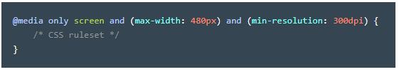

By placing the and operator between the two media features, the browser will require both media features to be true before it renders the CSS within the media query. The and operator can be used to chain as many media features as necessary.

Comma Separated List

If only one of multiple media features in a media query must be met, media features can be separated in a comma separated list.

For example, if we needed to apply a style when only one of the below is true:

* The screen is less than 480 pixels wide
* The screen is in landscape mode

We could write:

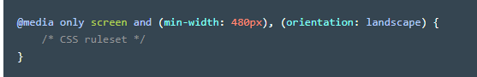

In the example above, we used a comma (,) to separate multiple rules. The example above requires only one of the media features to be true for its CSS to apply.

Note that the second media feature is orientation. The orientation media feature detects if the page has more width than height. If a page is wider, it's considered landscape, and if a page is taller, it's considered portrait.

# Breakpoints

We know how to use media queries to apply CSS rules based on screen size and resolution, but how do we determine what queries to set?

The points at which media queries are set are called breakpoints. Breakpoints are the screen sizes at which your web page does not appear properly. For example, if we want to target tablets that are in landscape orientation, we can create the following breakpoint:

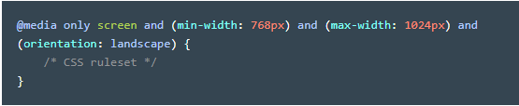

The example above creates a screen size range the size of a tablet in landscape mode and also identifies the orientation.

However, setting breakpoints for every device imaginable would be incredibly difficult because there are many devices of differing shapes and sizes. In addition, new devices are released with new screen sizes every year.

Rather than set breakpoints based on specific devices, the best practice is to resize your browser to view where the website naturally breaks based on its content. The dimensions at which the layout breaks or looks odd become your media query breakpoints. Within those breakpoints, we can adjust the CSS to make the page resize and reorganize.

By observing the dimensions at which a website naturally breaks, you can set media query breakpoints that create the best possible user experience on a project by project basis, rather than forcing every project to fit a certain screen size. Different projects have different needs, and creating a responsive design should be no different.

Check out [this](https://s3.amazonaws.com/codecademy-content/courses/freelance-1/unit-5/screen-sizes.png) list of breakpoints by device widths. Use it as a reference of screen widths to test your website to make certain it looks great across a variety of devices.